




Botanical Oracle-

ML-Powered Predictions for tree Resilience

SmartInternz
www.smartinternz.com

ML-Powered Predictions for tree Resilience

Predicting tree survival based on various environmental factors and seedling traits is a crucial area of
research that can provide insights into forest ecology, conservation efforts, and sustainable management
. practices. Just as Consumer Price Indices (CPI) provide valuable insights into economic trends, machine
learning models can be employed to predict seedling survival in diverse ecological contexts

Technical Architecture:

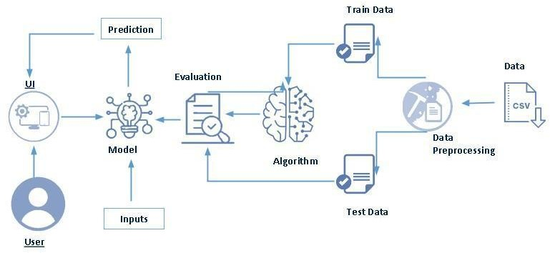

Pre requisites:
To complete this project, you must require following software’s, concepts and packages
- Anaconda navigator and PyCharm:
  - Refer the link below to download anaconda navigator
  - Link: https://youtu.be/1ra4zH2G4o0
- Python packages:
  - Open anaconda prompt as administrator
  - Type “pip install NumPy” and click enter.
  - Type “pip install pandas” and click enter.
  - Type “pip install scikit-learn” and click enter.
  - Type” pip install matplotlib” and click enter.
  - Type” pip install SciPy” and click enter.
  - Type” pip install pickle-mixing” and click enter.
  - Type” pip install seaborn” and click enter.
  - Type “pip install Flask” and click enter.

Prior Knowledge:
You must have prior knowledge of following topics to complete this project.
- ML Concepts
  - Supervised learning: https://www.javatpoint.com/supervised-machine-learning
  - Unsupervised learning: https://www.javatpoint.com/unsupervised-machine-learning
  - Decision tree: https://www.javatpoint.com/machine-learning-decision-tree-classification-algorithm
  - Random forest: https://www.javatpoint.com/machine-learning-random-forest-algorithm
  - KNN: https://www.javatpoint.com/k-nearest-neighbor-algorithm-for-machine-learning
  - Xg-boost: https://www.analyticsvidhya.com/blog/2018/09/an-end-to-end-guide-to-understand-the-math-behind-xgboost/
  - Evaluation metrics: https://www.analyticsvidhya.com/blog/2019/08/11-important-model-evaluation-error-metrics/
- Flask Basics: https://www.youtube.com/watch?v=lj4I_CvBnt0

Project Objectives:
By the end of this project, you will:
- Know fundamental concepts and techniques used for machine learning.
- Gain a broad understanding about data.
- Have knowledge on pre-processing the data/transformation techniques on outlier and some visualization concepts.

Project Flow:
- User interacts with the UI to enter the input.
- Entered input is analyzed by the model which is integrated.
- Once model analyses the input the prediction is showcased on the UI To accomplish this, we have to complete all the activities listed below,
- Define Problem / Problem Understanding
  - Specify the business problem
  - Business requirements
  - Literature Survey
  - Social or Business Impact.
- Data Collection & Preparation
  - Collect the dataset
  - Data Preparation
- Exploratory Data Analysis
  - Descriptive statistical
  - Visual Analysis
- Model Building
  - Training the model in multiple algorithms
  - Testing the model
- Performance Testing & Hyper parameter Tuning
  - Testing model with multiple evaluation metrics
  - Comparing model accuracy before & after applying hyper parameter tuning
- Model Deployment
  - Save the best model
  - Integrate with Web Framework
- Project Demonstration & Documentation
  - Record explanation Video for project end to end solution
  - Project Documentation-Step by step project development procedure

Prior Knowledge:
You must have prior knowledge of following topics to complete this project.
- ML Concepts
  - Supervised learning: https://www.javatpoint.com/supervised-machine-learning
  - Unsupervised learning: https://www.javatpoint.com/unsupervised-machine-learning
- Decision tree: https://www.javatpoint.com/machine-learning-decision-tree-classification- algorithm
- Random forest: https://www.javatpoint.com/machine-learning-random-forest-algorithm
- KNN: https://www.javatpoint.com/k-nearest-neighbor-algorithm-for-machine-learning
- Xgboost: https://www.analyticsvidhya.com/blog/2018/09/an-end-to-end-guide-to- understand-the-math-behind-xgboost/
- Evaluation metrics: https://www.analyticsvidhya.com/blog/2019/08/11-important-model- evaluation-error-metrics/
- Flask Basics: https://www.youtube.com/watch?v=lj4I_CvBnt0

Project Structure:
Create the Project folder which contains files as shown below
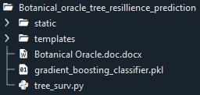

- We are building a flask application which needs HTML pages stored in the templates folder and a python script app.py for scripting.
- tree_surv.pkl is our saved model. Further we will use this model for flask integration.
- Training folder contains a model training file.

Milestone 1: Define Problem / Problem Understanding

Activity 1: Specify the business problem

The business problem revolves around optimizing forestry management, enhancing supply
chain sustainability, and informing investment decisions by accurately predicting tree survival
using machine learning. This predictive modeling aids in resource allocation, risk mitigation,
and policy formulation, aligning economic growth with environmental sustainability and
regulatory compliance. Leveraging ecological data and seedling traits, businesses and
policymakers can drive innovation, achieve strategic objectives, and foster resilient,
sustainable forestry practices.

Activity 2: Business requirements

Here are business requirements for tree survival project:

• Data Integrity: Ensure accurate, validated datasets for environmental factors and seedling traits.

• Model Transparency: Disclose machine learning algorithms, methodologies, and performance metrics.

• Platform Accessibility: Develop user-friendly interfaces for data visualization and decision-making.

• Compliance & Security: Adhere to ethical standards, data privacy regulations, and implement security protocols.

• Stakeholder Engagement: Foster collaboration, feedback mechanisms, and continuous model

refinement.

Activity 3: Literature Survey (Student Will Write)

A literature survey for Tree Survival Prediction entails:

Survival Analysis Techniques: Explore methodologies and their implications.

Data Acquisition: Assess data sources, quality, and relevance.

Machine Learning Models: Review algorithms, emphasizing accuracy and applicability.

Research Insights: Summarize key findings on tree survival factors.

Methodological Approaches: Analyze techniques like ensemble methods in tree survival prediction.

Challenges: Identify issues such as environmental variability and propose mitigation strategies.

Research Gaps: Highlight literature shortcomings and project contributions.

Activity 4: Social or Business Impact.

Social Impact: A Tree Survival Prediction project guides conservationists and policymakers in enhancing forest sustainability, biodiversity, and community well-being.

Business Impact: The project enables forestry businesses to optimize operations, mitigate risks, and ensure profitability through informed resource allocation and sustainable practices.

Milestone 2: Data Collection & Preparation
ML depends heavily on data. It is the most crucial aspect that makes algorithm training possible. So, this section allows you to download the required dataset.

Activity 1: Collect the dataset

There are many popular open sources for collecting the data. Eg: kaggle.com, UCI repository, etc.
In this project we have used .csv data. This data is downloaded from kaggle.com. Please refer to the link given below to download the dataset.
Link: https://www.kaggle.com/datasets/yekenot/tree-survival-prediction

As the dataset is downloaded. Let us read and understand the data properly with the help of some visualization techniques and some analyzing techniques.
Note: There are a number of techniques for understanding the data. But here we have used some of it. In an additional way, you can use multiple techniques.

Activity 1.1: Importing the libraries

Import the necessary libraries as shown in the image.

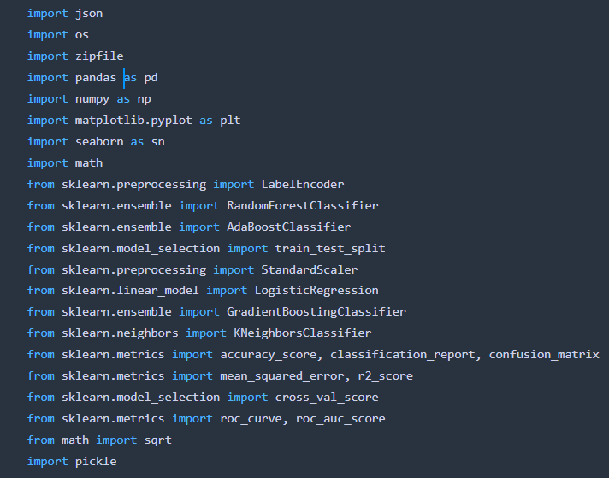

Activity 1.2: Read the Dataset

Our dataset format might be in .csv, excel files, txt, Json, etc. We can read the dataset with the help of pandas.
In pandas we have a function called read_csv () to read the dataset. As a parameter we have to give the directory of the csv file.

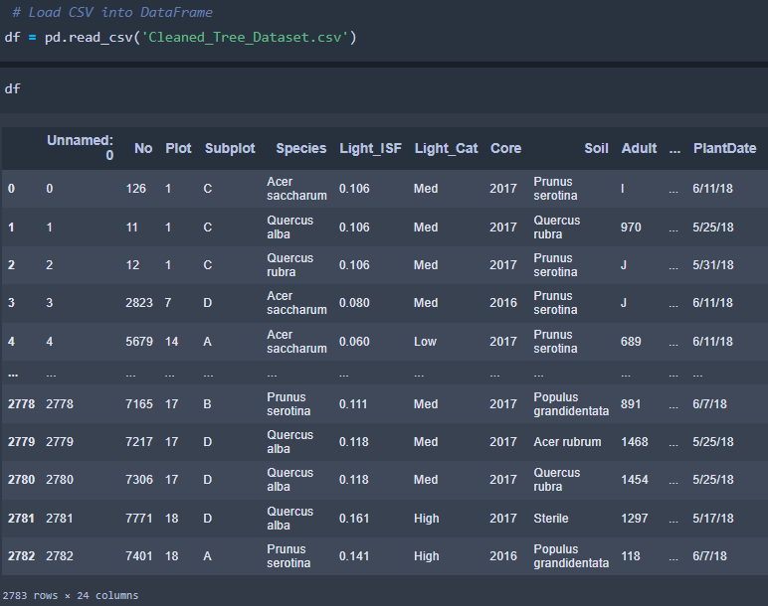

Activity 2: Data Preparation

As we have understood how the data is, let's pre-process the collected data.

The download data set is not suitable for training the machine learning model as it might have so much randomness so we need to clean the dataset properly in order to fetch good results. This activity includes the following steps.
- Handling missing values
- Handling categorical data
- Handling Outliers

Note: These are the general steps of pre-processing the data before using it for machine learning. Depending on the condition of your dataset, you may or may not have to go through all these steps.

Activity 2.1: Handling missing values

- Let’s find the shape of our dataset first. To find the shape of our data, the df. shape method is used. To find the data type, df.info () function is used.

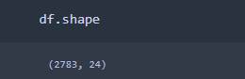

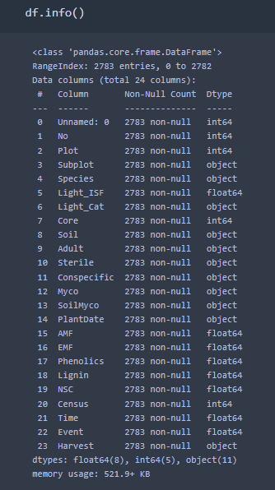

- For checking the null values, df. isnull () function is used. To sum those null values, we use. sum () function. From the below image we found that there are null values present in our dataset.
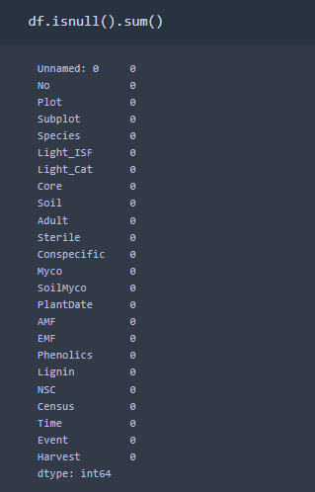

- We observed that there is no null values in this data set.

Activity 2.2: Handling Categorical Values

As we can see our dataset has categorical data, we must convert the categorical data to integer encoding or binary encoding.
To convert the categorical features into numerical features we use encoding techniques. There are several techniques but, in our project, we are using Label encoding.
  - In our project, there are 10 categorical features. With label encoding we converted them into numbers.

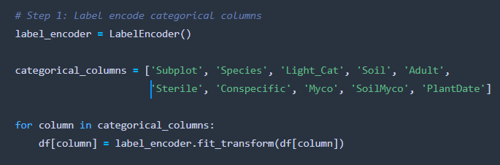

Activity 2.3: Handling Imbalance Data

In our data set there is no imbalance data. So, we skip this step.

Milestone 3: Exploratory Data Analysis

Activity 1: Descriptive statistical

Descriptive analysis is to study the basic features of data with the statistical process. Here pandas have a worthy function called describe. With this describe function we can understand the unique, top and frequent values of categorical features. And we can find mean, std, min, max and percentile values of continuous features.

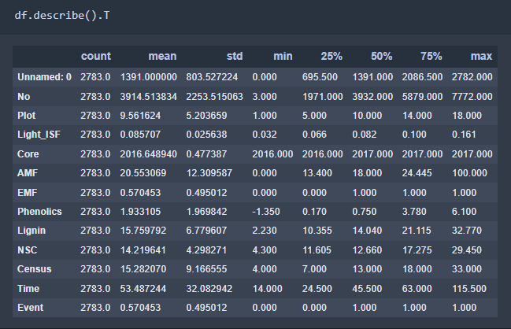

Activity 2: Visual analysis

Visual analysis is the process of using visual representations, such as charts, plots, and graphs, to explore and understand data. It is a way to quickly identify patterns, trends, and outliers in the data, which can help to gain insights and make informed decisions.

Activity 2.1: Univariate analysis

In simple words, univariate analysis understands the data with single feature. Here we have displayed two different graphs such as distplot and count plot.
Seaborne package provides a wonderful function distplot. With the help of distplot, we can find the distribution of the feature. To make multiple graphs in a single plot, we use subplot.

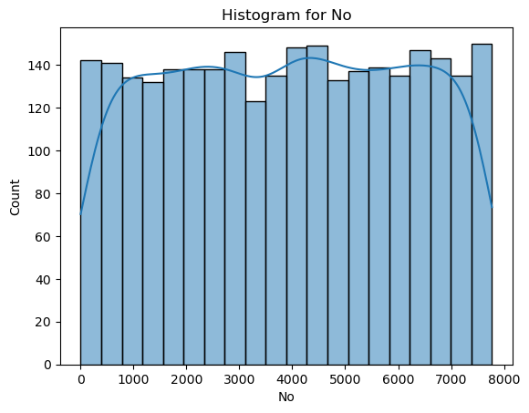

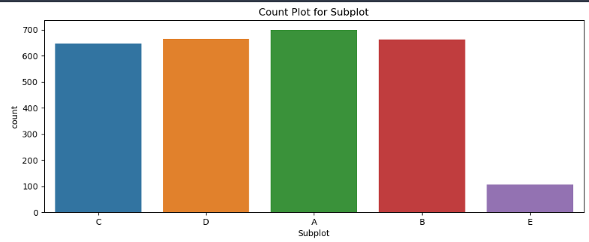

Activity 2.2: Bivariate analysis

To find the relation between two features we use bivariate analysis. Here we are visualizing the relationship between Each feature with year. For example

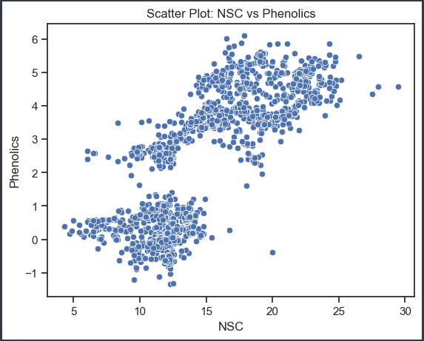

- Here we used scatter plot between NSC and phenolics. we can observe here how data points scattered .and we can check outliers also through scatter plot.

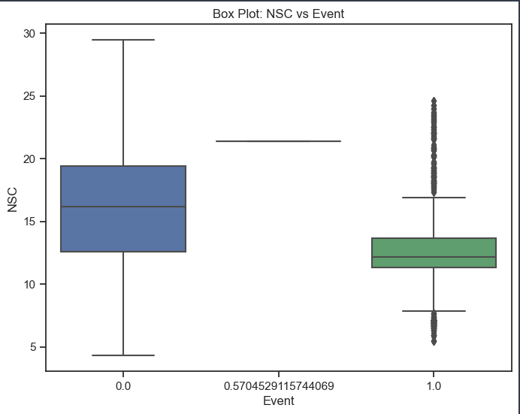

- Here we used box plot between Event (Target variable) and Time to check outliers and data points centered around median. Here we can observe in 2nd boxplot there are outliers. And median value is not mid value means data distribution is skewed with respect to Event

Activity 2.3: Multivariate analysis

We use heat map to check multicollinearity.

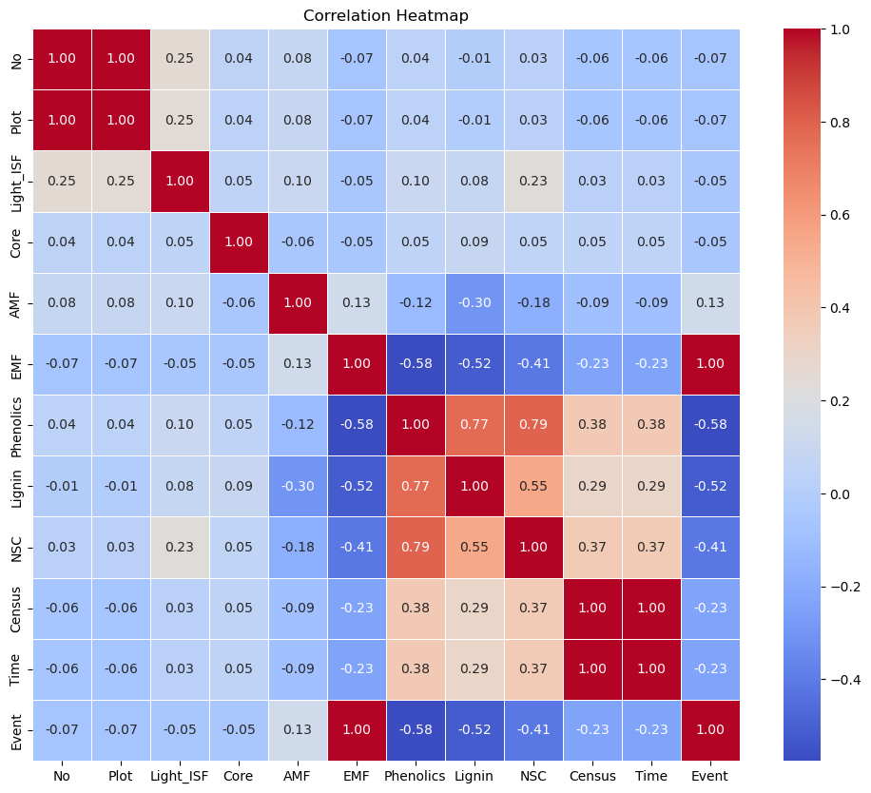

Here we can observe Time and census is corelated each other 100%.and variable
‘NO’ and plot also have same collinearity means they are providing same kind of
information so we can drop one of them.

Activity 4: Scaling
As we have different scales of data, in order to make good predictions using a model,
we are currently in the process of scaling our data. First split the dataset into Features
and y_label. For scaling we are imported standard Scaler from sklearn then applied
scaling to features

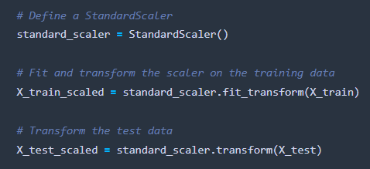

Activity 5: Splitting data into train and test

Now let’s split the Dataset into train and test sets. First split the dataset into x and y and then split the data set
Here x and y variables are created. On x variable, df is passed with dropping the target variable. And on y target variable is passed. For splitting training and testing data we are using train_test_split () function from sklearn. As parameters, we are passing x, y, test size, random state.
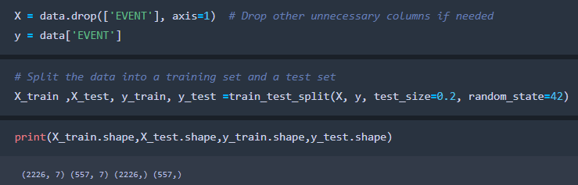

Milestone 4: Model Building

Activity 1: Training the model in multiple algorithms
Now our data is cleaned and it’s time to build the model. We can train our data on different algorithms. For this project we are applying three regression algorithms. The best model is saved based on its performance.

Activity 1.1: Logistic Regression model

A function named logistic regression created and train and test data are passed as the parameters. Inside the function, Logistic regression algorithm is initialized and training data is passed to the model with. fit () function. Test data is predicted with. predict () function and saved in new variable. For evaluating the model, Calculates the confusion matrix and analyses classification report.
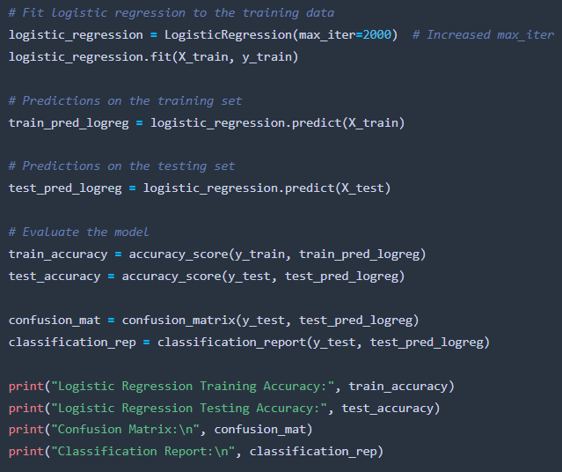

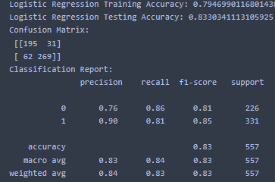

The logistic regression model is quite accurate, with around 83.30% correct predictions on
new data it means model is overfit . The confusion matrix shows 269 correct positive
predictions and 31 incorrect ones. In simpler terms, the model is good at identifying both
classes, with balanced accuracy for positive and negative outcomes.

Activity 1.2: Random forest model

A function named Random Forest Regression created and train and test data are passed as the parameters. Inside the function, Lasso regression algorithm is initialized and training data is passed to the model with. fit () function. Test data is predicted with. predict () function and saved in new variable. For evaluating the model, Calculates the confusion matrix and analyses classification report.
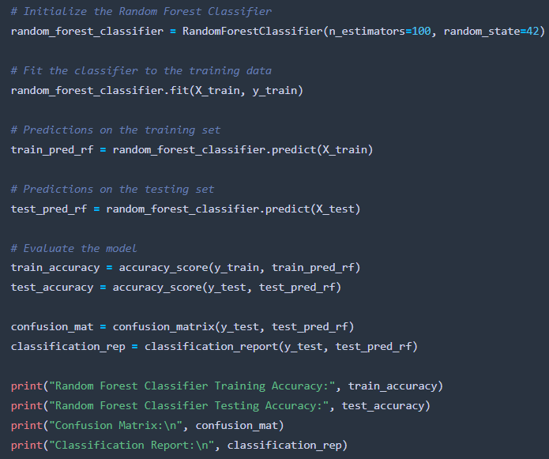

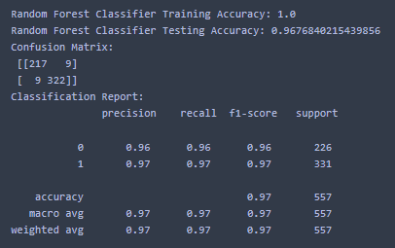

here we can observe The Random Forest Classifier is highly accurate, achieving a perfect

100% on training data and about 96.77% on new test data.

The confusion matrix shows only a few misclassifications with 322 correct positive.

predictions. In simpler terms, this model is very effective, with nearly all predictions being

accurate especially for the positive outcomes .

Activity 1.3: Ada Boost
A function named Ad boost created. and train and test data are passed as the parameters. Inside the function, Lasso regression algorithm is initialized and training data is passed to the model with. fit () function. Test data is predicted with. predict () function and saved in new variable. For evaluating the model, Calculates the confusion matrix and analyses classification report.
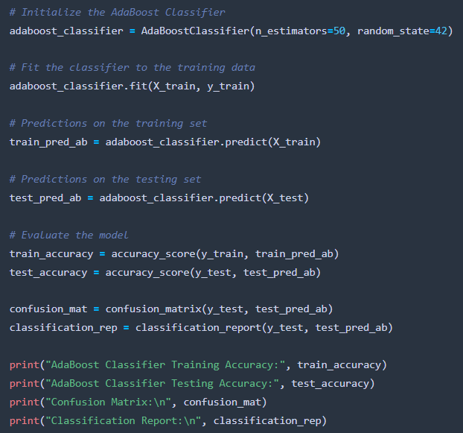

The AdaBoost Classifier performs well with a training accuracy of 96.50% and a
testing accuracy of 94.97%. The confusion matrix indicates 315 correct positive.
predictions with a balanced 12 false positives. In simpler terms, the model is quite
effective, achieving high accuracy rates and showing strong performance in both
precision and recall metrics, especially for predicting positive outcomes

Activity 1.4: Gradiant_boosting
A function named Gradiant_boosting created. and train and test data are passed as the parameters. Inside the function, Lasso regression algorithm is initialized and training data is passed to the model with. fit () function. Test data is predicted with. predict () function and saved in new variable. For evaluating the model, Calculates the confusion matrix and analyses classification report.

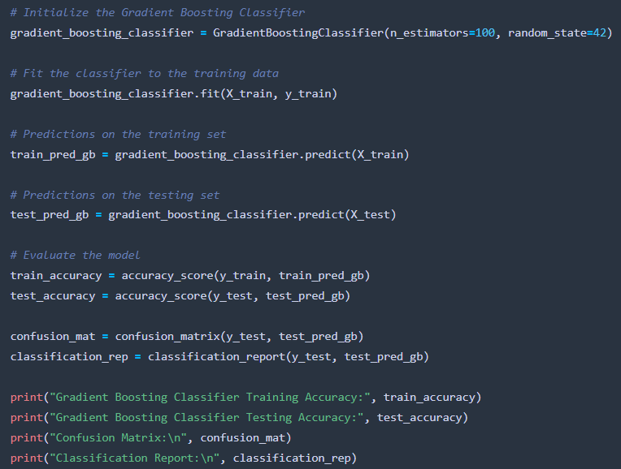

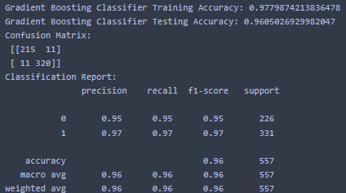

The Gradient Boosting Classifier achieves a high training accuracy of 97.80% and a
commendable testing accuracy of 96.05%. The model's confusion matrix shows minimal
misclassifications, with 320 true positives and 11 false positives. Overall, it demonstrates
robust performance in accurately classifying instances, balancing precision, recall, and
reliability.

Activity 1.5: KNN model

A function named KNN is created and train and test data are passed as the parameters. Inside the function, KNeighborsClassifier algorithm is initialized and training data is passed to the model with. fit () function. Test data is predicted with. predict () function and saved in new variable. For evaluating the model, Calculates the confusion matrix and analyses classification report.
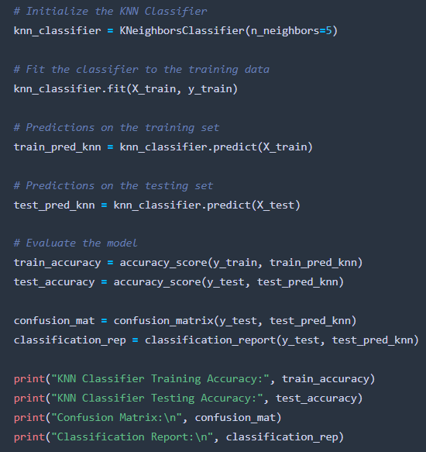

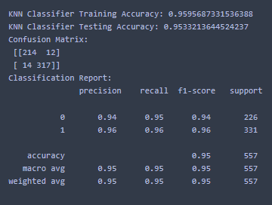

The KNN Classifier achieves a training accuracy of 95.96% and a testing accuracy of
95.33%. The confusion matrix reveals 317 true positives and 12 false positives,
indicating solid classification performance. Overall, with balanced precision, recall,
and accuracy metrics.

Activity 2: Testing the model

Here we have tested with Gradient boosting algorithm (final model). You can test with all algorithm. With the help of predict () function.
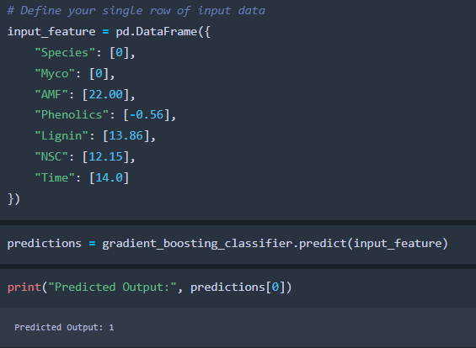

Milestone 5: Performance Testing & Hyperparameter Tuning

Activity 1: Comparing model accuracy before & after applying hyper parameter tuning (Hyper parameter tuning is optional). For this project it is not required.)

Milestone 6: Model Deployment

Activity 1: Save the best model

Saving the best model after comparing its performance using different evaluation metrics means selecting the model with the highest performance and saving its weights and configuration. This can be useful in avoiding the need to retrain the model every time it is needed and also to be able to use it in the future.
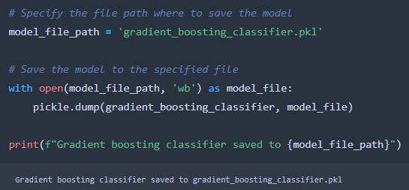

Activity 2: Integrate with Web Framework

In this section, we will be building a web application that is integrated to the model we built. A UI is provided for the uses where he has to enter the values for predictions. The enter values are given to the saved model and prediction is showcased on the UI.
This section has the following tasks

- Building HTML Pages
- Building server-side script
- Run the web application

Activity 2.1: Building Html Pages:

For this project create two HTML files namely

- Index.html
- Inner-page.html
- output

and save them in the templates folder. Refer this link for templates.

Activity 2.2: Build Python code:

Import the libraries
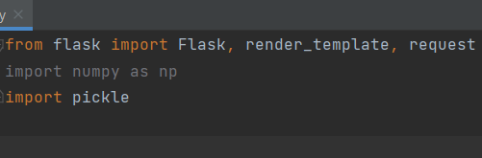

Load the saved model. Importing the flask module in the project is mandatory. An object of Flask class is our WSGI application. Flask constructor takes the name of the current module ( name ) as argument.

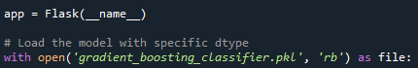

Render HTML page:

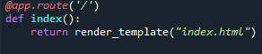

Here we will be using a declared constructor to route to the HTML page which we have created earlier.

In the above example, ‘/’ URL is bound with the home.html function. Hence, when the home page of the web server is opened in the browser, the html page will be rendered. Whenever you enter the values from the html page the values can be retrieved using POST Method.

Retrieves the value from UI:
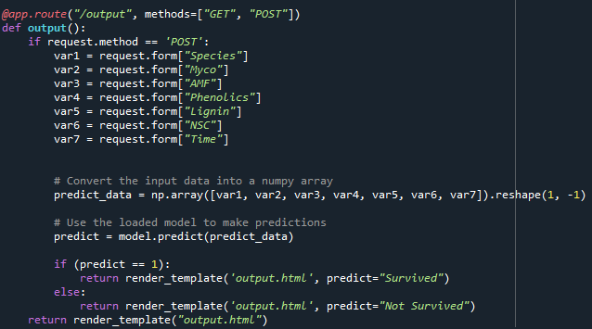

Here we are routing our app to predict () function. This function retrieves all the values from the HTML page using Post request. That is stored in an array. This array is passed to the model. Predict () function. This function returns the prediction. And this prediction value will be rendered to the text that we have mentioned in the submit.html page earlier.
Main Function:
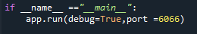

Activity 2.3: Run the web application

  - Open anaconda prompt from the start menu
  - Navigate to the folder where your python script is.
  - Now type “tree_surv.py” command
  - Navigate to the localhost where you can view your web page.
  - Click on the predict button from the top left corner, enter the inputs, click on the submit button, and see the result/prediction on the web.
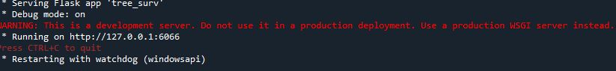

Now, Go the web browser and write the localhost URL (http://127.0.0.1:6066) to get the below result

